Dear Eagle Parents/Guardians,

Welcome to the 2023-2024 school year! It is with great excitement that I introduce myself to you as the new Senior Principal of Jubilee Highland Hills. I am honored to have the opportunity to work alongside dedicated educators and committed parents. I have been a devoted and passionate educator for nineteen years. During that time, I worked with students from pre-kindergarten to college. I am thrilled that my journey has brought me back to Jubilee Academies!

Along with Mrs. Evans, Mrs. Sundvall, Ms. Polk, teachers, and staff, I will work hard to continue to build strong relationships with you, your child, and the community. Jubilee Highland Hills will continue to provide a nurturing community focused on leadership and educational excellence where all students have the opportunity to thrive.

The implementation of our Determined Destiny Values will continue to provide our students with an understanding of what it means to be disciplined, empathetic, goal-oriented, respectful, responsible, and self-aware. Our teachers remain committed to implementing effective instructional practices to prepare your child to be in control of their destiny. Our leadership team will continue to lead the school community by cultivating an encouraging, inclusive, safe, and supportive learning environment.

Please feel free to call or email me to discuss any concerns you might have throughout the school year. Let’s work together to ensure that your child has a successful academic year.

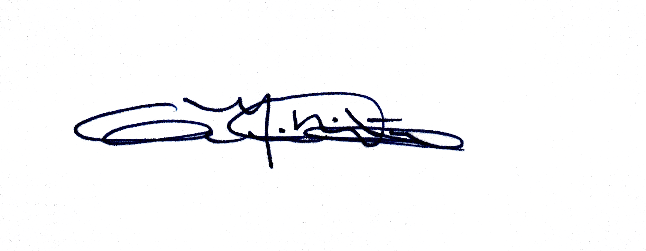
Respectfully,

Geneva M. RicoWatson, Ph.D.
Jubilee Highland Hills, Senior Principal
geneva.ricowatson@jubileeacademic.org
(210) 634-7590 ext. 12128

